Nama : Muhamad Nur Alim

NIM : 18090040

Kelas : 5B

**Laporan Pratikum 2**

1. Source Code

Latihan1.php → controller

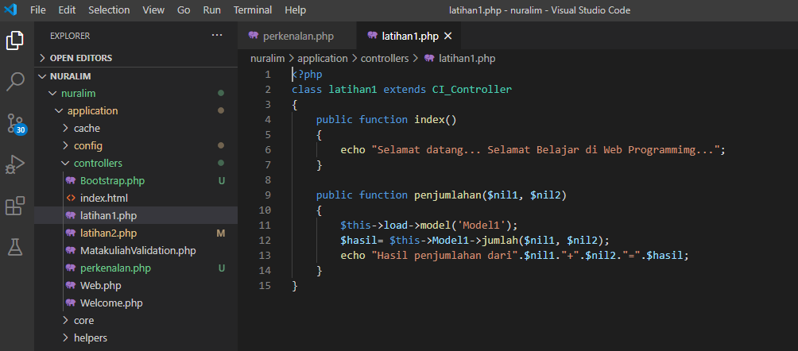

Latihan2.php → controller

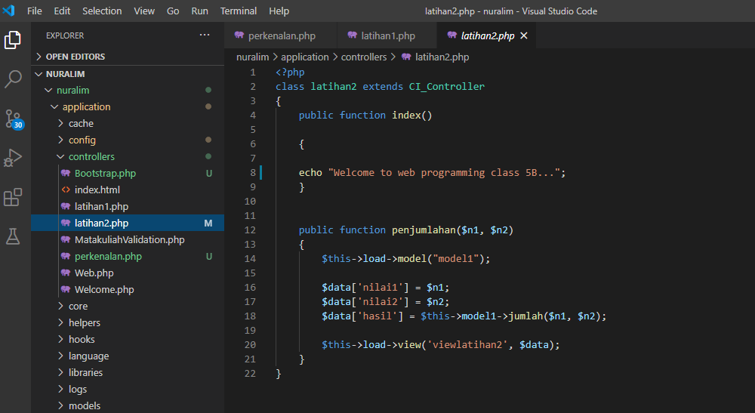

Models.php → models

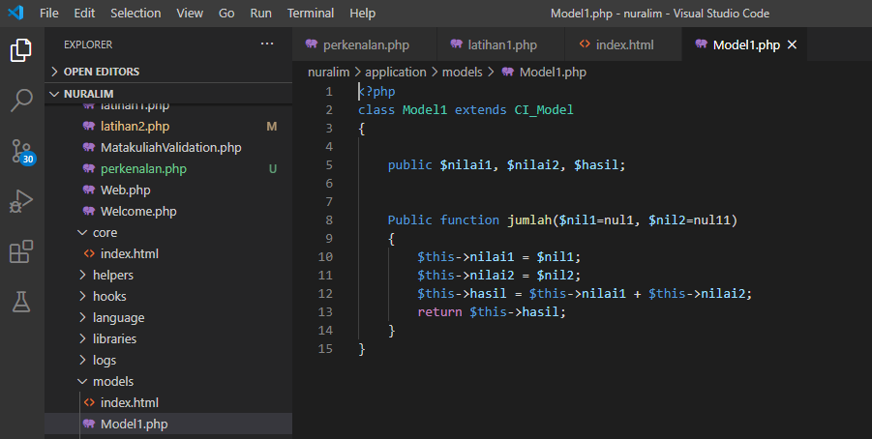

View-viewlatihan2.php → views

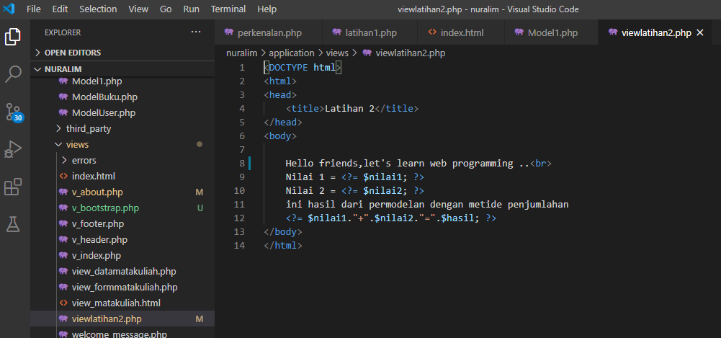

1. Capture Output Program

Latihan 1

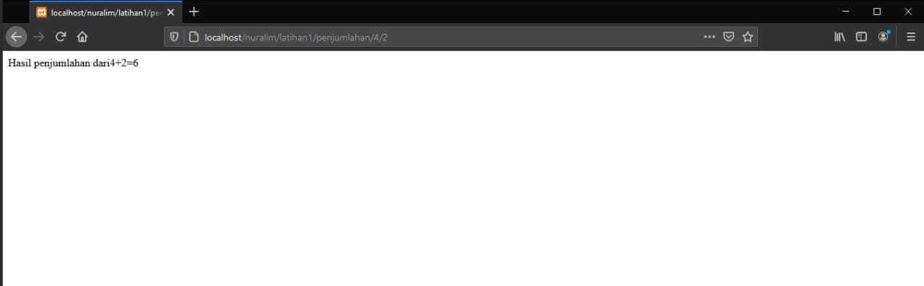

Latihan 2

